Crook County Library, Oregon
Strategic Plan
2025-2030

541-447-7978 library@crooklib.org

Welcome to

Crook County Library!

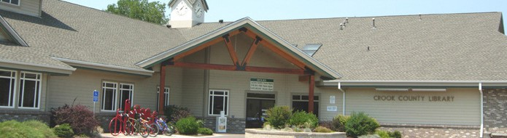

Contents

- Letter from the Director
- Our community
- Our library
- Vision
- Mission
- Values
- Roles of the Library
- Goals of the Library
- Strategies
- Success measures
- Our process
- Acknowledgements

"The only thing that you absolutely have to know, is the location of the library."-Albert Einstein

A letter from our Director-
Libraries are more than books and ideas. Libraries are community-building spaces where residents of all ages come together to visit, share, learn from each other, and discover. As we reimagine library spaces and offerings to bring the greatest value to Crook County residents, we also realize the library’s greatest asset…our wonderful library patrons!
The Crook County Library Strategic Plan 2025-2030 is now complete. Thank you for participating in the strategic planning process through the community task force, town halls meetings, focus groups, key informant interviews, and your 400+ survey responses.
The Strategic Framework 2025-2030, vetted by community residents, will move us into the future in the most responsible and thoughtful way…2030 here we come! With Outreach into rural areas of Crook County a priority, a new branch up Juniper Canyon is on our to-do list. Rural Services in Paulina, Post and at Brothers Elementary School have already started, and a new Paulina Library Branch will be a wonderful community gathering place for local residents living in the Upper Country. We are planning to offer library services at other rural locations through the Bookmobile and would like to hire a bilingual employee.
Whether you are 0 or 100, Crook County Library is a place for early literacy and lifelong education. Free baby board book kits are distributed to each expectant family. Kits include an invitation to visit the Crook County Library to get a free library card, a free baby board book and information on Dolly Parton’s Imagination Library and the one thousand Books Before Kindergarten program!
Tweens and teens looking for something to do? Visit the new Teen space filled with areas for gaming, homework and studying/laptop bar, arts and crafts materials, job information and space for classes on life skills. If you know of a teen who needs to learn how to make pizza dough or change a tire, send them on down to the Crook County Library!
Need information on local resources? Visit Thrive or DHS to discover basic needs options available for you and your family. Ask for a list of local services at the front desk.
You might even get to enjoy some world-class entertainment such as the Glenn Miller Orchestra!

Whether you visit the Crook County Library for books, educational information, general information about community services, or quality arts and crafts classes or wonderful performances, your Crook County Library has something for everyone!

Please stop by for a visit and pick up your free Crook County Library card. Where else can you check out for free almost a million eContent items!

Have a wonderful year and we hope to see you at the Crook County Library!

Sarah Beeler, Crook County Library Director.

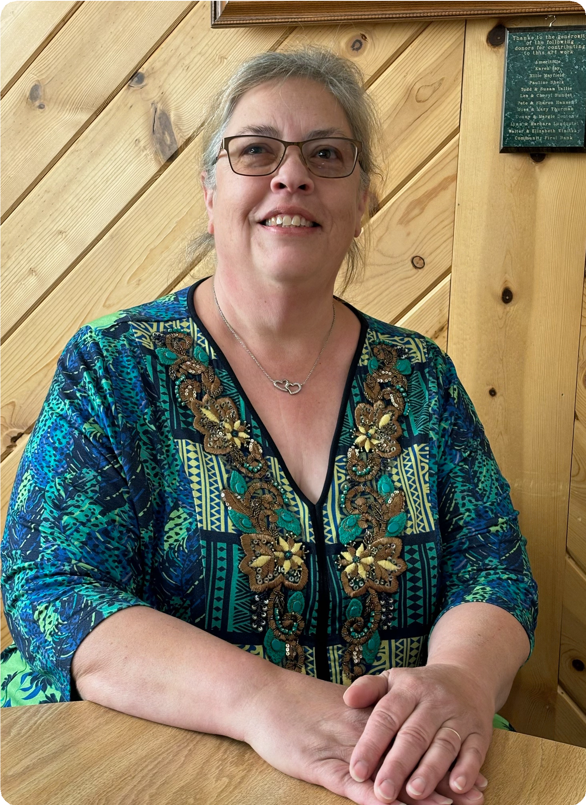

Our Community

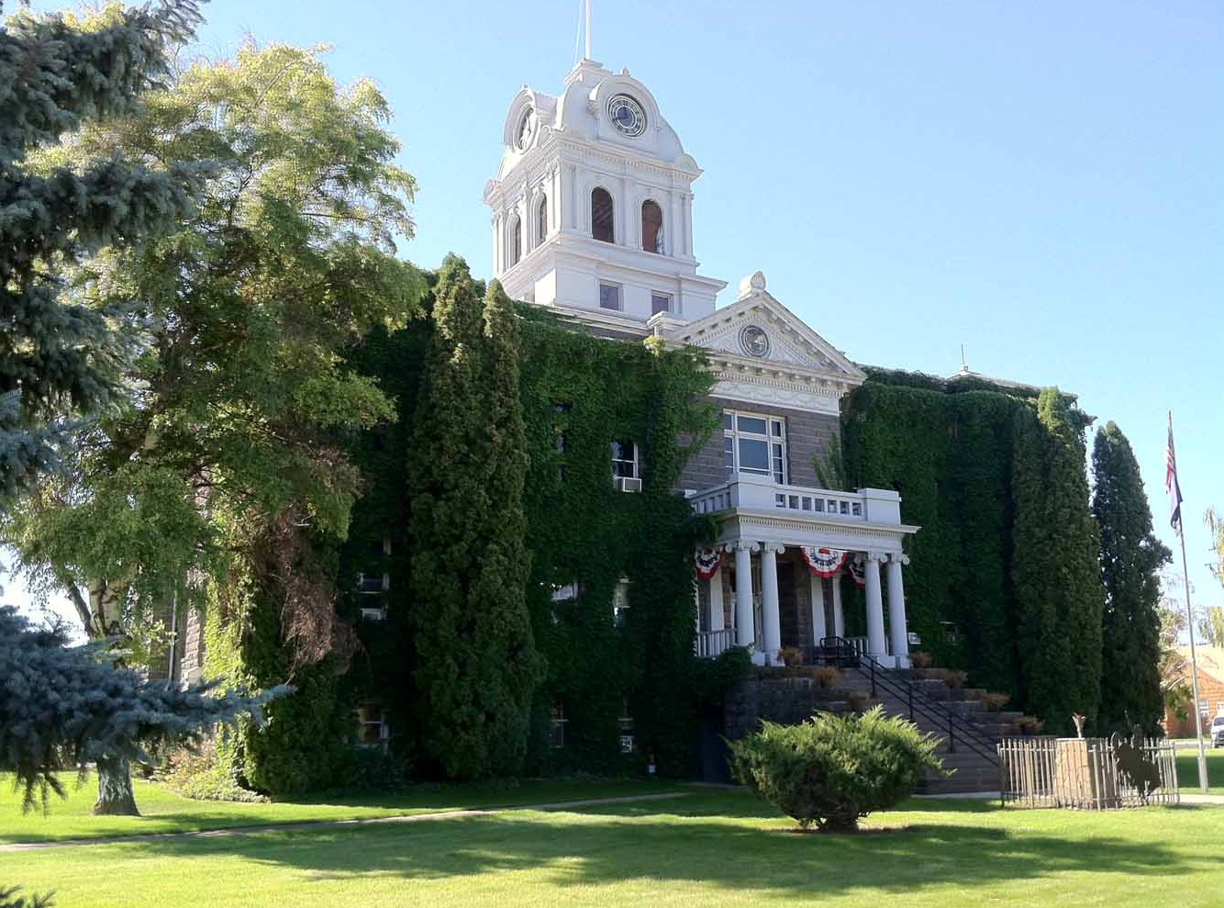

Crook County is located in the geographic center of Oregon. Formed from Wasco County in 1882 and named for Major General George Crook, Crook County only has one incorporated population center, the City of Prineville founded in 1868.

Crook County was the fastest growing county in Oregon between 2020 and 2022. No longer the state’s top county for population growth, it is still one of the top 10 fastest growing counties in Oregon.

Experience the natural beauty of Crook County when visiting Steins Pillar, Prineville Reservoir State Park, Crooked River Scenic Drive, and many other scenic locations where Mountain Bluebirds are as plentiful as spring wildflowers.

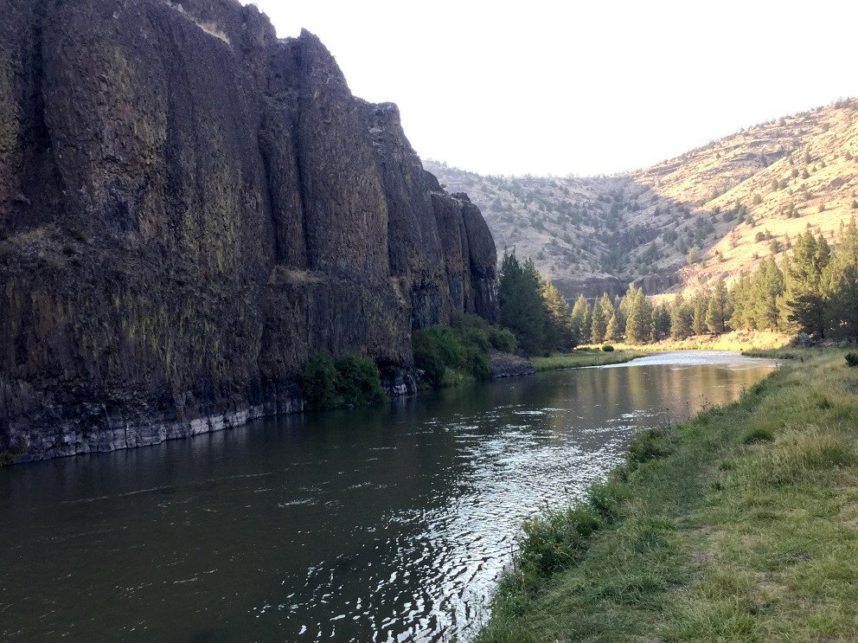
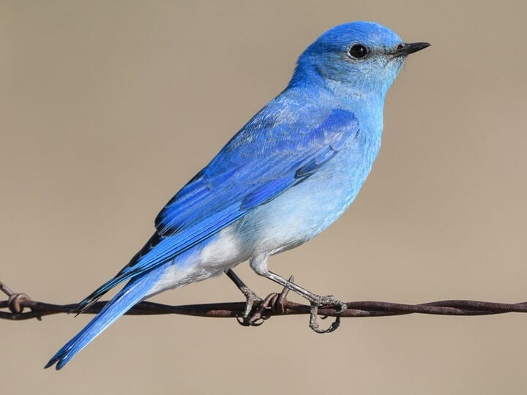

Our Library

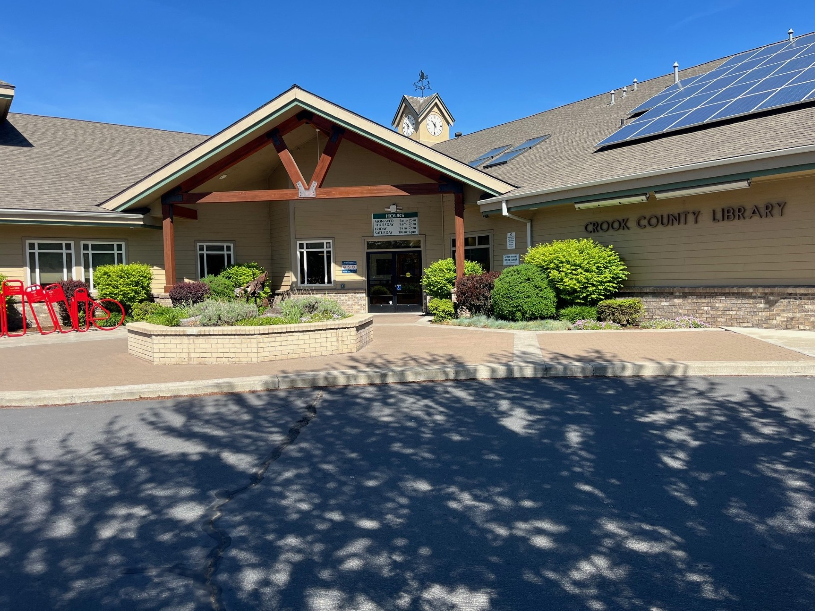
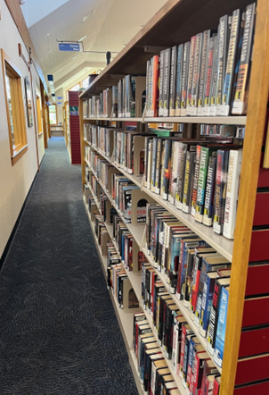

In 1876, Sarah Joanne Yancey and four other Crook County ladies were responsible for starting a reading group, which consisted of ordering a book from the printing houses in New York City. They took turns reading the book and then discussed it. One of their husbands built a shelf in the basement of the Crook County Courthouse. They would put the books there, and that was the start of the first lending library in Crook County. The Crook County Court formally established the Crook County Library in 1931. The library was housed in several rooms of the Courthouse at the request of the Crook County Library Club. After a successful bond measure and fundraising campaign, a 17,500 square foot library facility was constructed for a population of 16,000 on the corner of 2nd Street and Meadow Lakes Drive.

There were over 169,065 public service transactions last year: visits to the library, books, e-books, and media checked out, public computer sessions, programs attended by children and families, teens, and adults, and assistance with finding information that helps people in their daily lives. There are 50,009 total physical items owned. Crook County Library is a net lender. This means Crook County Library loans more materials to Deschutes Public Library and Jefferson County Public Library than we borrow. There are almost one million items available in the digital collection through Library2Go and Libby apps.

Circulation per capita is 4.8 (circulation divided by population). State average is 15.4. Library services to rural Crook County is a priority!

Crook County Library has robust partnerships with Bowman Museum, Crook County On the Move, Thrive, DHS, Brothers Elementary School, Crook County Schools, Paulina School, and Powell Butte Community Charter School. Crook County Library values and appreciates support from the Crook County Friends of the Library, the Crook County Library Board, State Library of Oregon, library volunteers, summer/winter reading program sponsors!

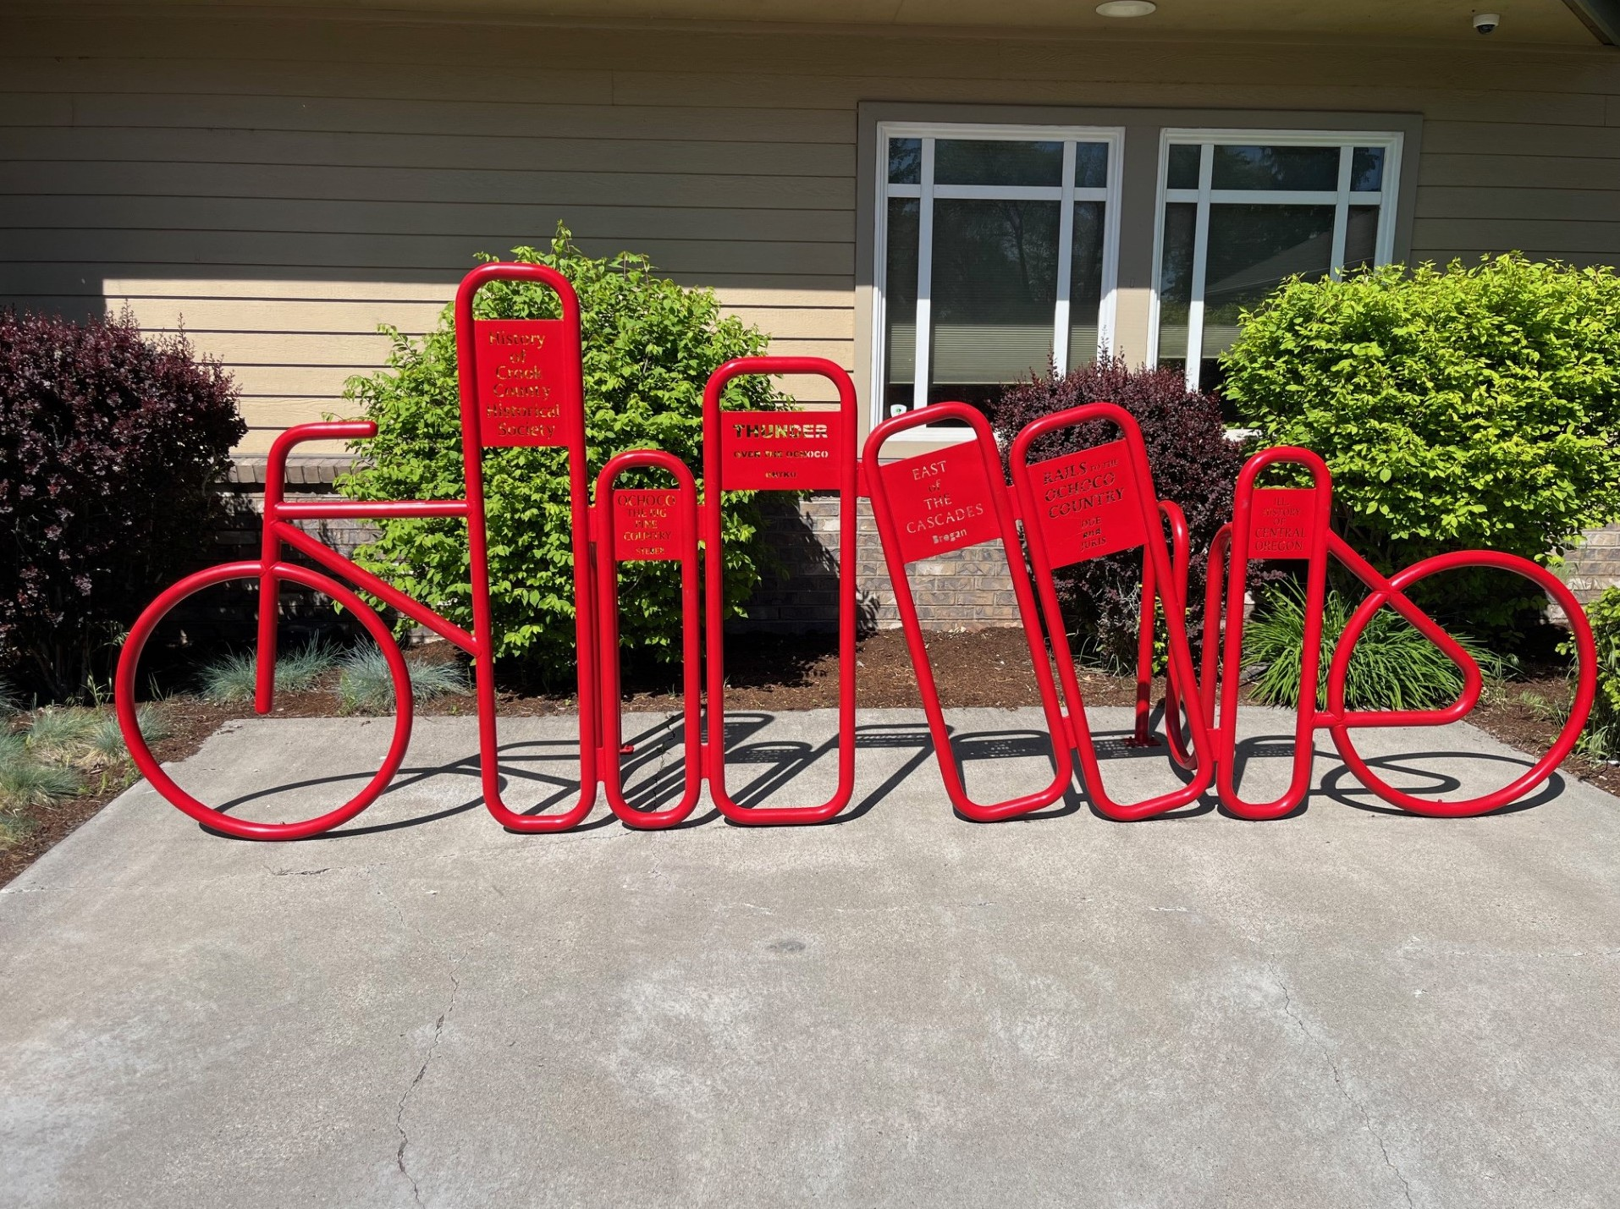
Future Dreams and Aspirations include library services to rural Crook County Communities. Maybe even a new library branch in Paulina and Juniper Canyon!

Vision |  | Mission
The Crook County Library is the respected, trusted community learning hub that is used, supported, and beloved by all residents and visitors. |  | Be a welcoming presence and resourceful anchor for our community’s learning, enjoyment, and inspiration.

Values

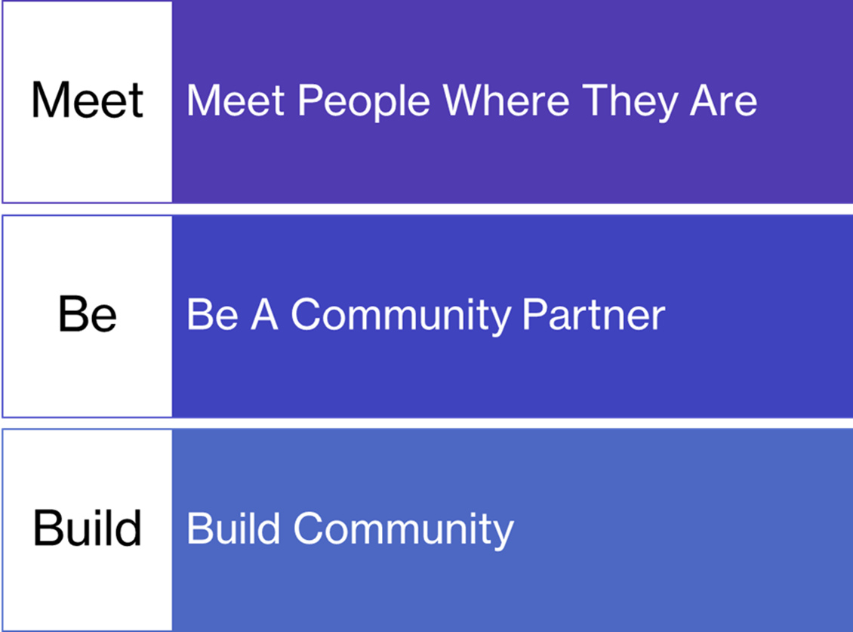

Roles of the Library
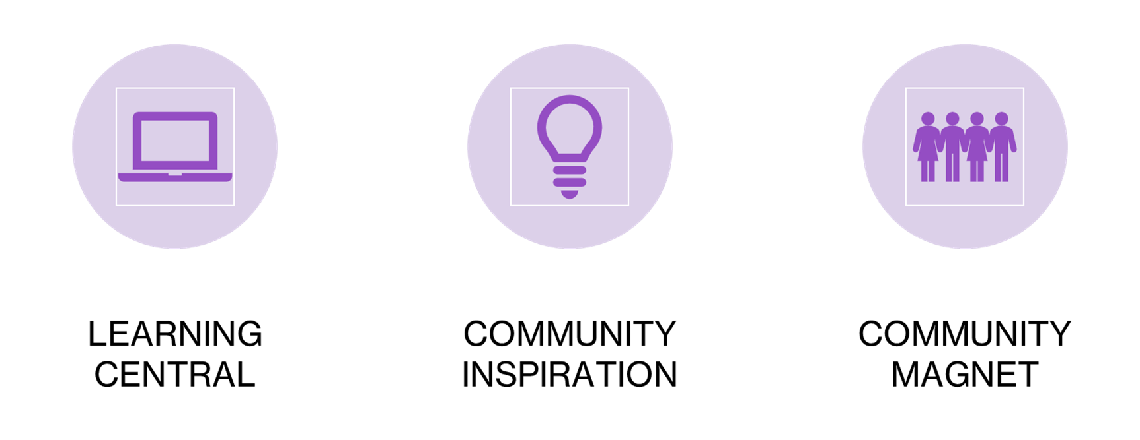

Learning Central
The library of the future is the place that instantly comes to mind when people want to learn anything and everything throughout their lives. It is the place that supports young people’s learning from birth through teen years, their parents and teachers too. Library staff help individuals find what they need to know in print and digital collections. They help match individuals to online courses and trainings including those that are free to library users. The library provides programs of interest to the community, such as on health and wellness, emerging technology, and it is a portal to the region and the world through offerings that are generally free to library users, like its Discovery Pass Program. Library visitors can find out about community services and resources, such as emergencies, mental health, housing, youth programs, religious options, transportation, and so forth.
Community Inspiration
The library of the future enriches the lives of residents with events and performances that entertain, celebrate, and inspire the community. Examples are author visits, poetry and storytelling events, musical events, dramatic performances and historical and cultural displays and festivals. These events renew spirits, inspire creativity, and build community.
Community Magnet
The library of the future is a destination for everyone in the community. Its location in Prineville along with possible future locations make it more convenient for people throughout the county. Its online presence makes services available from wherever people are in the county. Its welcoming presence makes it a place where people meet, plan, connect, use services, belong, recreate, learn, and grow.

Goals of the Library
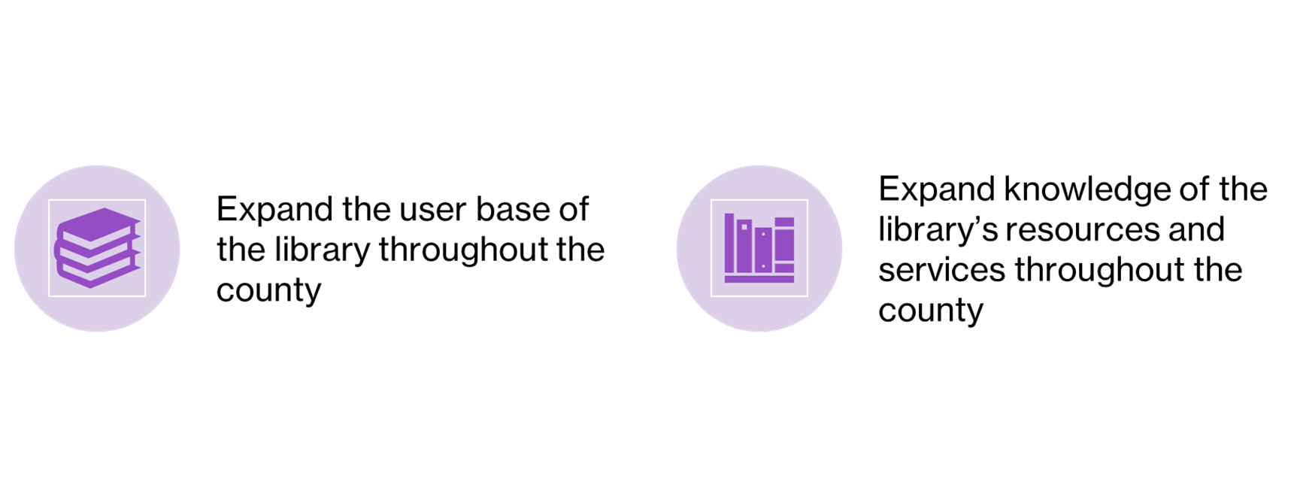

Future Imperatives

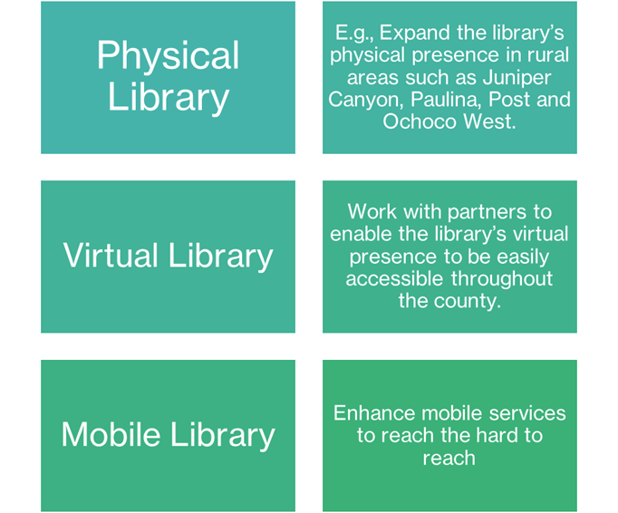

Success Measures
- Expand user base of the library throughout the county. Increase number of library card holders by 5% each year for the next 5 years.
- Expand knowledge of the library’s resources and services throughout the county.
Our Process
The Strategic Planning process included interviews with key community stakeholders, three Strategic Planning Task Force meetings and Town Halls. Thank you to all of the community members who took the time to fill out the Crook County Library Strategic Planning Survey. Over 417 surveys were returned! Crook County Library would also like to extend a special thanks to our strategic planning consultants: Ruth Metz Associates, Erin McCusker, and Brenda Valles. We appreciate your wisdom, knowledge, and strategic planning expertise!

Acknowledgments

Thank you for your help and assistance throughout the strategic planning process!

We couldn’t have done it without you!

Library Strategic Planning Task Force Members
- Natalie T. Good
- Sandy Kerbow
- Justin Smith
- Ashley Smith
- Faye Streier
- Jennifer Miles Orozco
- Gayle Casselman
- Toby Allen
- Mike Wilson
- Kathleen Wilson
- John Wagner
- Tom Evans
- Frank Porfily
- Carrie Gordon

Crook County Commissioners and Crook County Manager
- Commissioner Susie Hermreck
- Commissioner Brian Barney
- Commissioner Seth Crawford
- County Manager Andy Parks

Library Board of Trustees
- Natalie T. Good
- Sandy Kerbow
- Keye Rohovit
- Mark Maboll
- Keya Rohovit-Wrolson

Library Strategic Planning Team and Consultants
- Sarah Beeler, Director of Library Services
- Ruth Metz, Ruth Metz Associates
- Erin McCusker, Strategic Planning Consultant
- Brenda Valles, Strategic Planning Consultant

